How to purchase a single game voucher (SGV) in Netball Connect

- Access the Registration Form: Use the provided link to access the online registration form via Netball Connect here , https://registration.netballconnect.com/login
- If the participant has never created an account with Netball Connect, select New User – Register.
- If the participant has already downloaded the Netball Connect app and created an account, they can login using the same username (email) and password.
- If you have an account and have forgotten your password, please select Forgot/Reset Password
- If the participant is new, select +New Participant Registration then select who you are registering, either yourself, a family member or on behalf of someone else.
- If the participant already has an account, select the name of the participant you are registering.
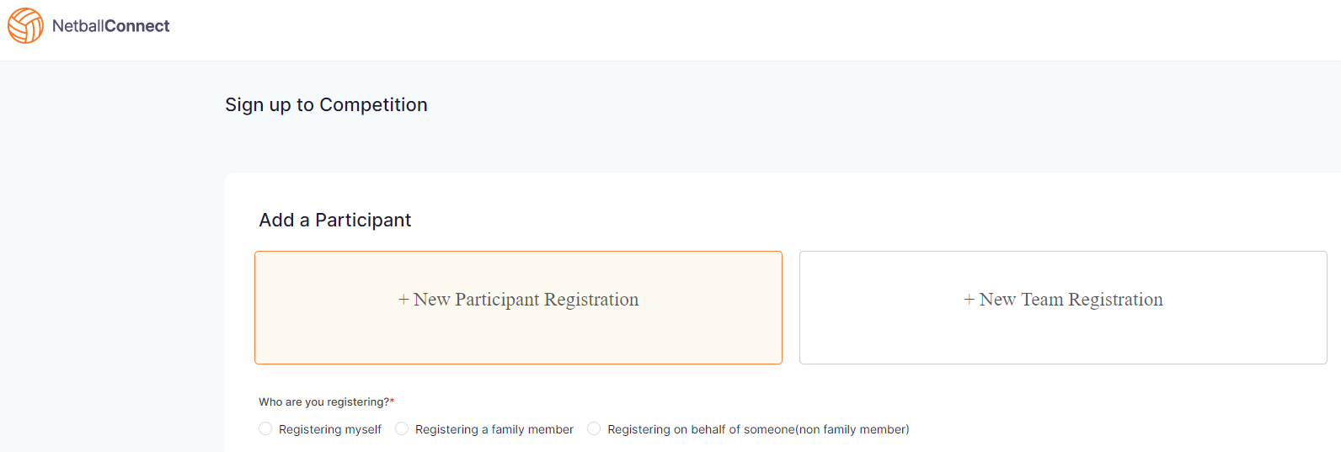
- Complete Participant Details: The registration process is as per the normal process for registering. Fill out the required personal details, ensuring you select the correct competition and team if prompted.
- Select the Voucher: On the final page before payment, look for the option to select "One Match Only" or a "Single Game Voucher" product. This is crucial for purchasing just one game.
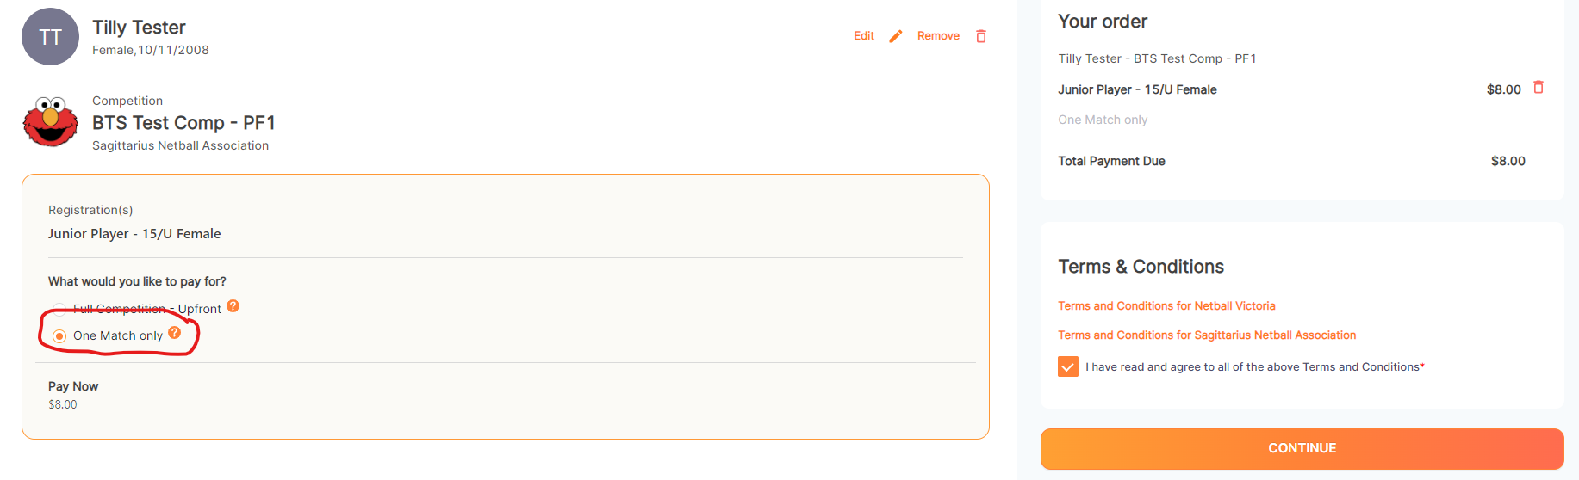
- Make Payment: Proceed through the payment steps to complete the transaction.
- Receive Confirmation: You will receive an email confirmation and the details will appear in your Netball Connect profile
- How to select them on the ipads for player attendance : A player who has purchased a Single Game Voucher should show up through the “borrow a player” button when completing team attendance on the ipads (completed by scorer or Team Manager)and will automatically add the player with the SGV and redeem the voucher).
Important Considerations:
- No In-Person Purchases:
SGVs can no longer be purchased at a venue on the day of the game.
- Unique Links:
The process relies on using the specific registration link provided by the club or association, not a general link.
- One-Time Use:
Each SGV is for a single game only and is not transferable or refundable if unused.

